|  |
| --- |
| MINISTRY OF EDUCATION AND SCIENCE OF UKRAINE  NATIONAL TECHNICAL UNIVERSITY  «KHARKIV POLYTECHNIC INSTITUTE»  Department of Software Engineering and Management Information Technologies  List of laboratory reports  discipline « Fundamentals of Operating System »  Executed by: Chukwu Irele omike  Student of group KH-201.8ei.1  Checked by:  Prof. S. L  Gloskakova Anna Alexandrouna  Kharkiv – 2019 |

MINISTRY OF EDUCATION AND SCIENCE OF UKRAINE

NATIONAL TECHNICAL UNIVERSITY

«KHARKIV POLYTECHNIC INSTITUTE»

Department of Software Engineering and Management Information Technologies

Report from lab № 1

discipline « Fundamentals of Operating System »

Kharkiv

2018

**Theme :**

**Installing Linux Ubuntu on a virtual machine VirtualBox**

**Objective:** Learn to install operating systems ,with virtual machines;

**Task:**

 install Virtual Box;

 install Linux on Virtual Box;

**Progress of the lab:**

Run Virtual Box setup;

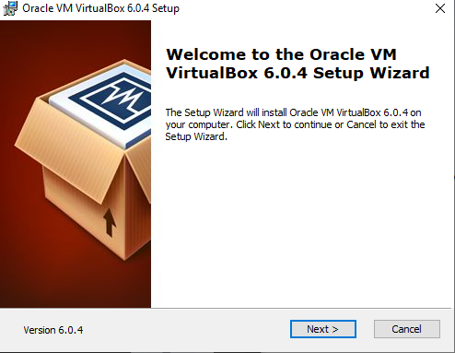

Wait for setup to run:

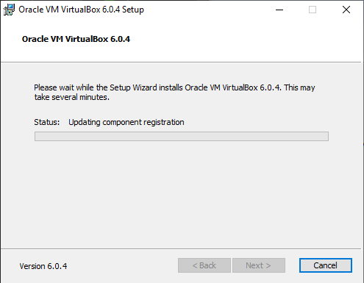

Select name and type of operating system intending to install:

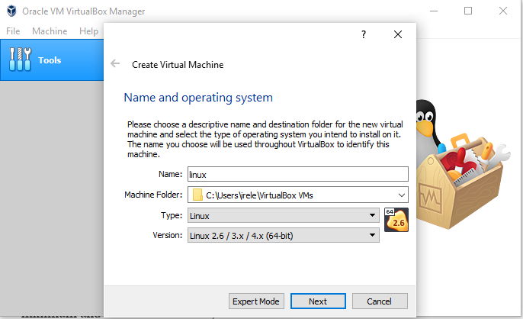

Select the memory size of the virtual machine :

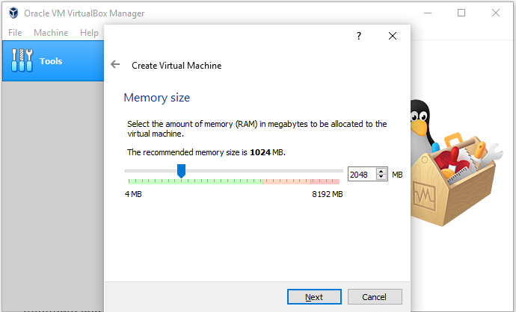

Select type of hard disk :

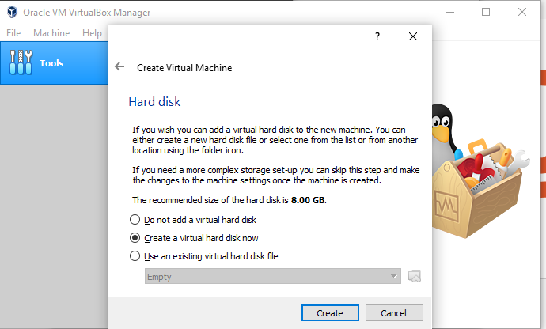

Select hard disk file type:

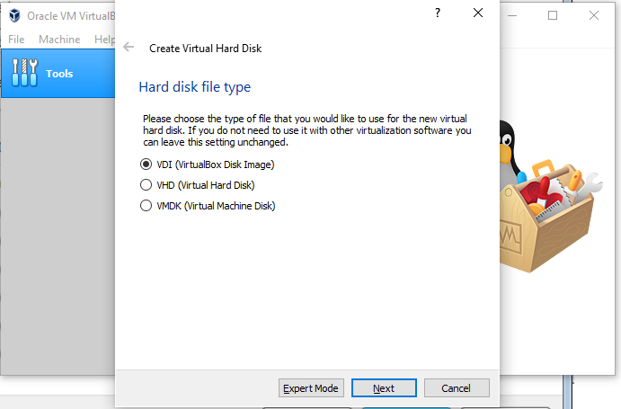

Select size of hard disk

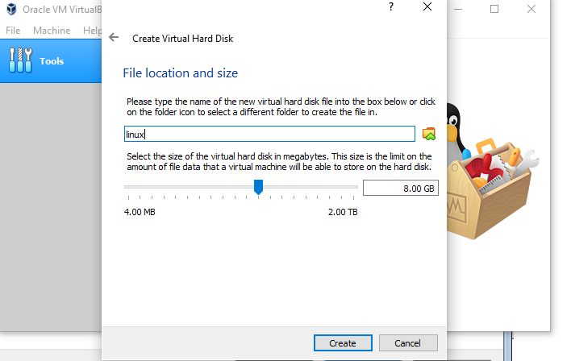

Virtual machine is ready ;

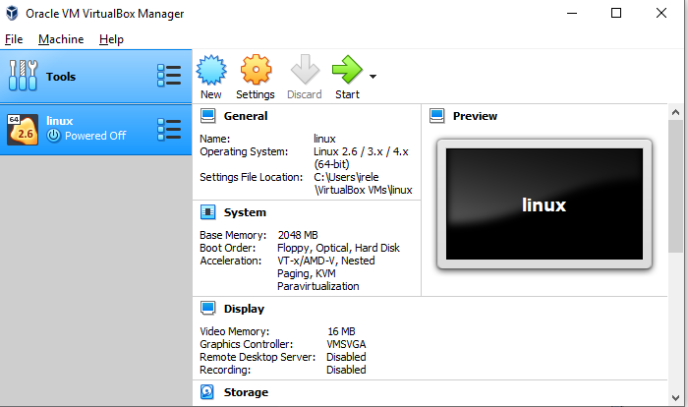

Select start-up disk:

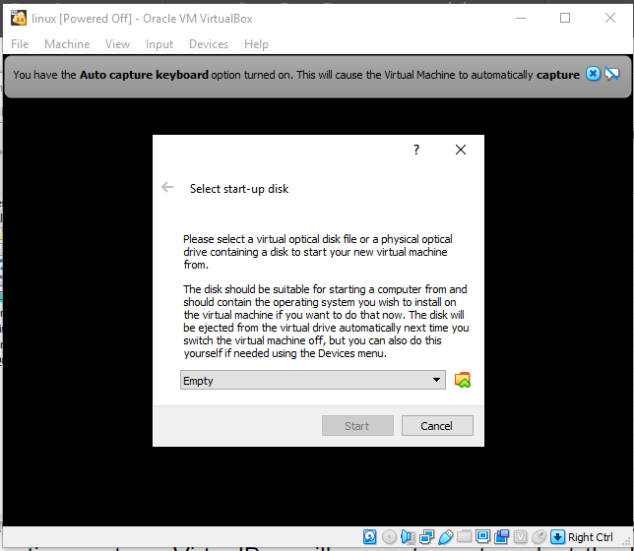

Select the optical disk for Ubuntu OS

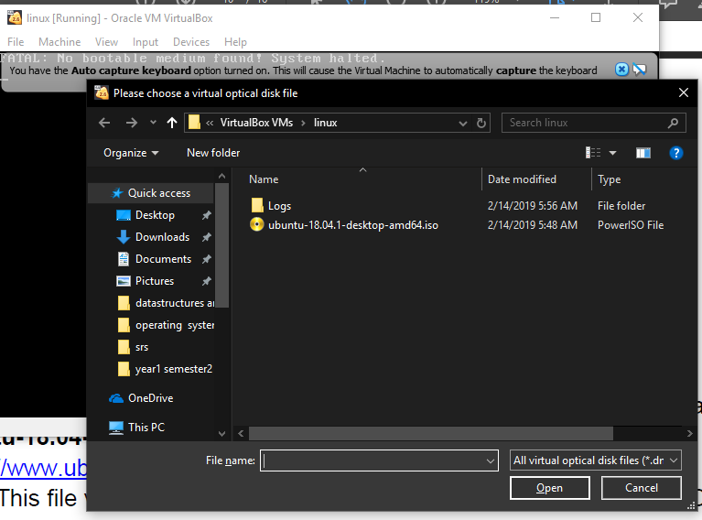

Select install Ubuntu

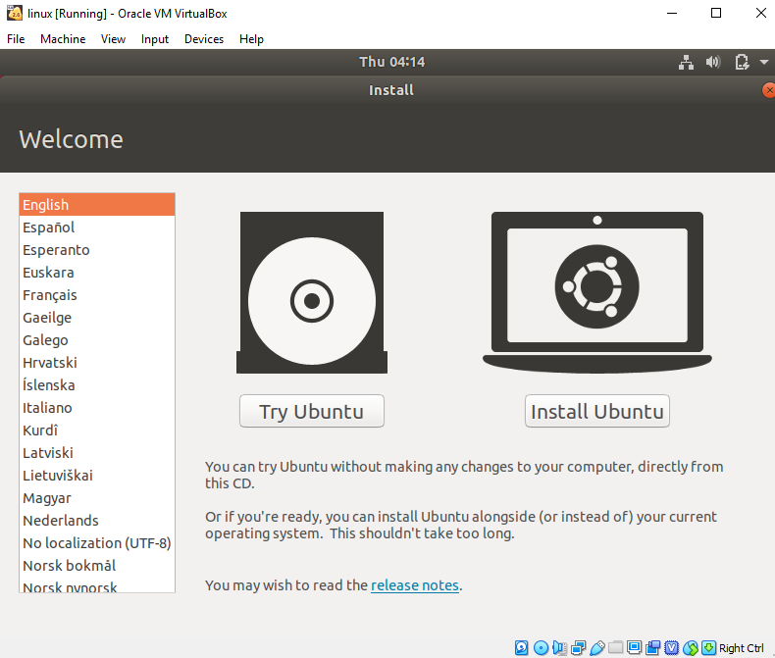

Choose to install updates:

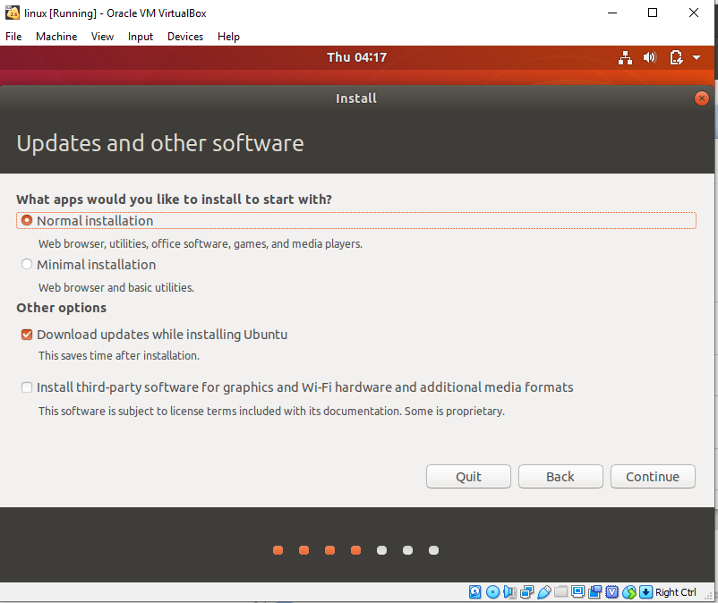

Select installation type:

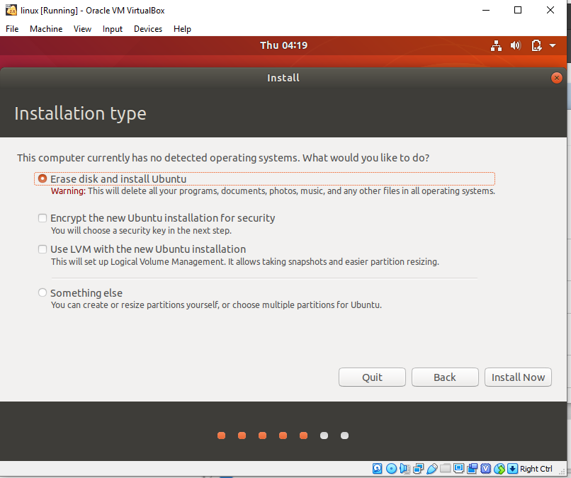

Enter user details

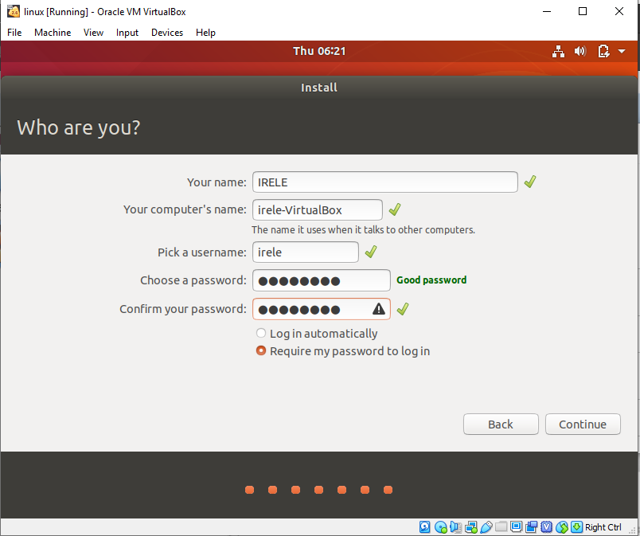

Installing :

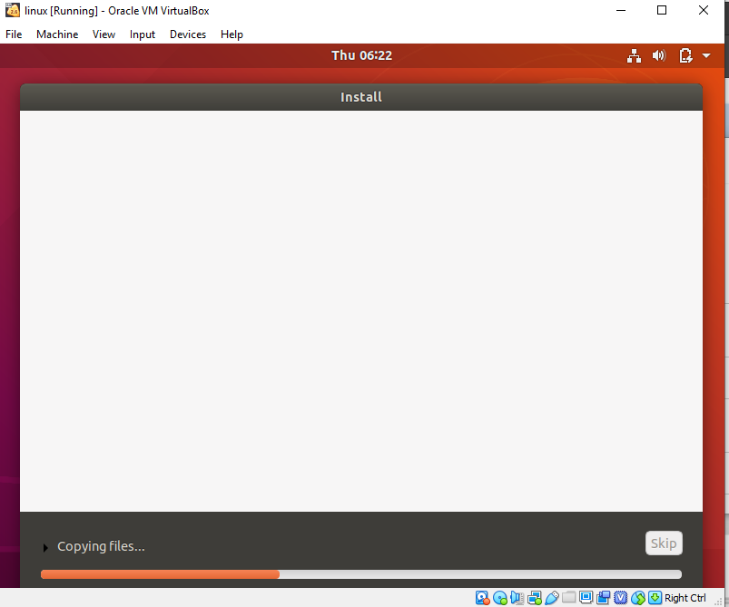

Installation done Restart

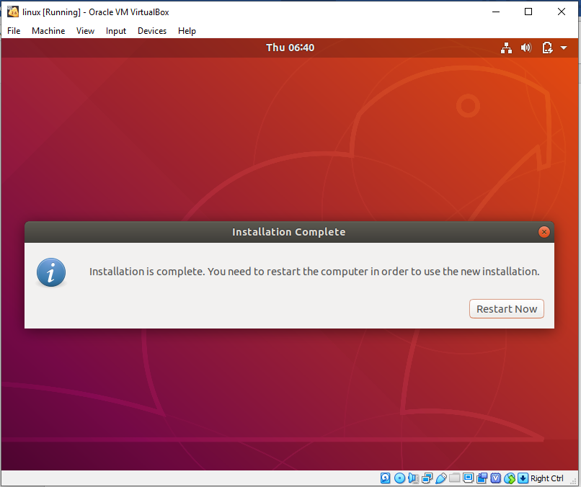

Login in into new user;

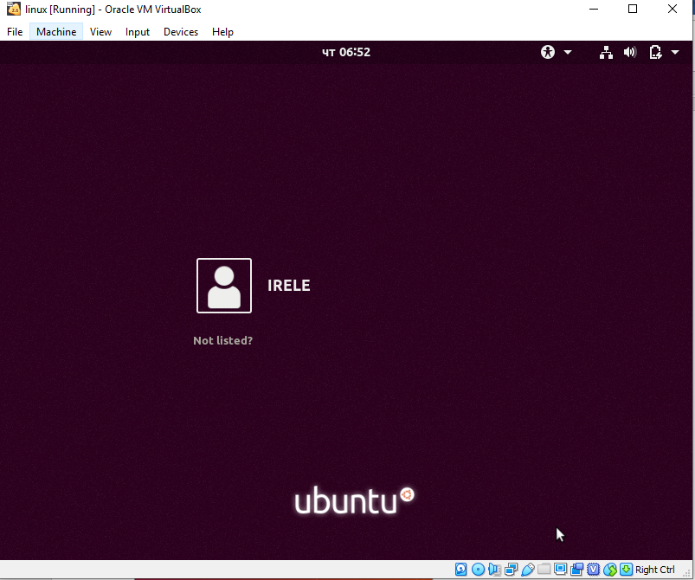

Ubuntu ready to use

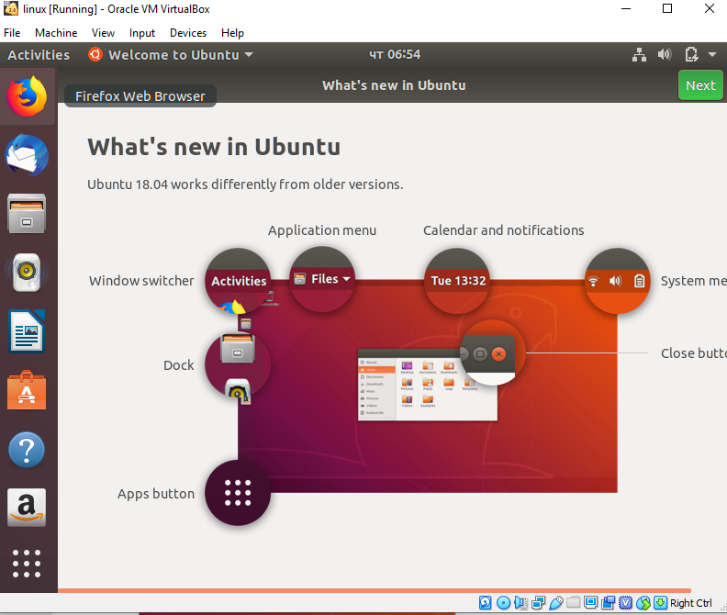

**Conclusion:**

In this laboratory the following was considered ;

* What is a virtual machine ,
* How to create a virtual machine
* How to install Ubuntu OS on the virtual machine
* How to configure the Ubuntu OS